# Chapter 23 – Finance, Saving, and Investment

**Financial Institutions and Financial Markets**

To study the economics of financial institutions and market we distinguish between:

*Finance and Money*

The study of finance looks at how households and firms obtain and use financial esources and how they cope with the risk that arise in this activity.

The study of money looks at how households and firms use it, how much of it they hold, how banks create and manage it, how its quantity influences the economy.

*Physical Capital ad financial capital*

Physical capital is the tools, instruments, machines, buildings, and other items that have been produced in the past and that are used today to produce goods and services.

The funds that firms use to buy physical capital are called financial capital.

*Capital and Investment*

**Gross Investment** is the total amount spend on purchases of new capital and on replacing depreciated capital.

**Depreciation** is the decrease in the quantity of capital that results from wear and tear and obsolescence.

**Net Investment** is the change in the quantity of capital.

$$Net Investent=Gross Investment -Decpreciation$$

*Wealth and Savings*

Wealth is the value of all the things that people own.

Savings is the amount of income that is not paid in taxes or spent on consumption of goods and services.

$$ΔWealth=Savings (Income-Net Taxes-Consumption)+Capital Gains/Losses$$

*Financial Capital Markets*

Savings are sources to funds used In finance investments and there are three types of financial markets which these funds are supplied to:

1. Loan Markets
2. Bond Markets
3. Stock Markets

*Financial Institutions*

A financial institution is a firm that operates on both sides of the markets for the financial capital. It is a borrower in one and lender in the other market.

Key financial institutions are

1. Banks
2. Trust and Loan Companies
3. Credit Unions and Caisses Populaires
4. Pension funds
5. Insurance Companies

*Insolvency and Illiquidity*

Net worth of a financial institution is the total market value of what it has lent minus the market value of what it has borrow.

If this net worth is positive then it solvent and can remain in business but if it is negative, the institution is insolvent and go out business.

Sometime a financial institution is solvent but illiquid – which means if a sudden demand for borrowed funds is there and it has all its funds in long term loans.

*Interest Rates and Asset Prices*

The interest rate on a financial asset is the interest received as a percentage of price of the asset deposited in the financial institution, usually the rates are for a year.

**The Loanable Funds Market**

The market for loanable funds is the aggregate of all the individual financial markets.

Funds that finance investments come from three sources:

1. Household Savings (S)
2. Government Budget surplus (T - G)
3. Borrowing from the rest of the world (M - X)

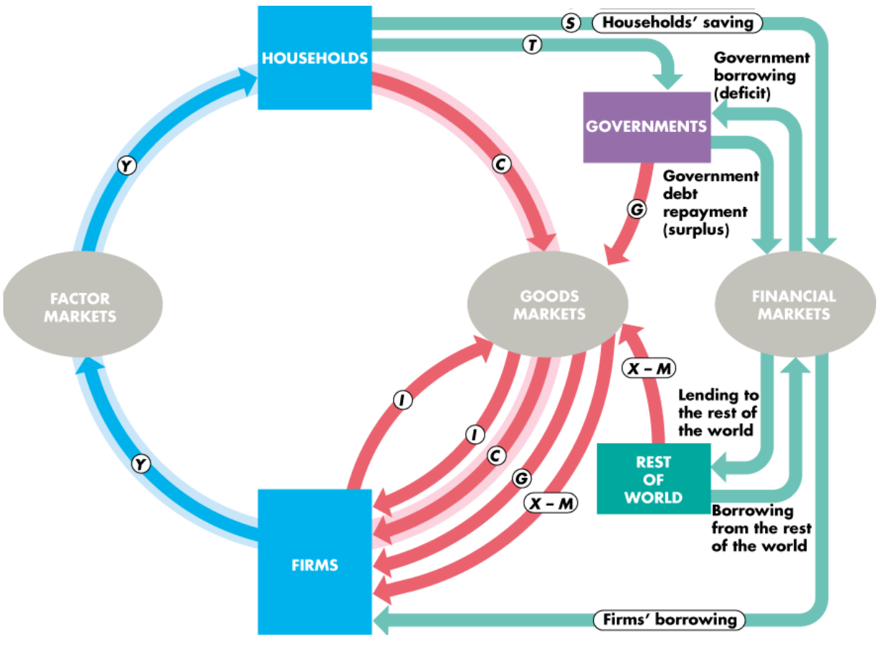

Figure 1 Flow of funds that finance the investment

*The Real Interest Rate*

The **Nominal interest rate** is the number of dollars that a borrower pay and lender receives in interest in a year expressed as a percentage of number of dollars borrowed and lent, whereas the **real interest rate** is adjusted for the effects of the inflation.

*The Demand for Loanable Funds Curve*

The demand for loanable funds is the relationship between quantity of loanable funds demanded and the real interest rate when all other factors remain the same.

Other things remaining the same, the greater the expected profit from new capital, the greater is the amount of investment and the greater the demand for loanable funds

*The Supply of Loanable Funds*

The supply of loanable funds depends on

1. The real interest rate
2. The disposable income
3. Expected future income
4. Wealth
5. Default Risk

The supply of loanable funds is the relationship between the quantity of loanable funds supplied and the real interest rate when all other influences on lending plans remain the same.

An increase in disposable income, a decrease in expected future income, a decrease in wealth, or a fall in default risk increases saving and increases the supply of loanable funds.

In the short run duration, there is a lot of volatility,

**Government in the Loanable Funds Market**

Government budget deficit increases the demand for funds, the real interest rate rises, saving increases, and investment decreases.

*Crowding-Out Effect*

The tendency for a government budget deficit to raise the real interest rate and decrease investment is called **crowding-out effect**.